31 August 2026



Assignment 1

Computer Networks
I-409-TSAM
Teacher: Fatima Zahra Errounda / Stephan Schiffel

Óli Daníel Brynjarsson
Eva Dís Hákonardóttir
Atli Friðgeirsson Axfjörð

Table of Contents
Task 1 1
A 1
B 2
C 2
D 2
E 2
Task 2 3

Task 1

A
The open TCP ports were:
22/tcp – SSH
2000/tcp – Cisco SCCP
5060/tcp – SIP
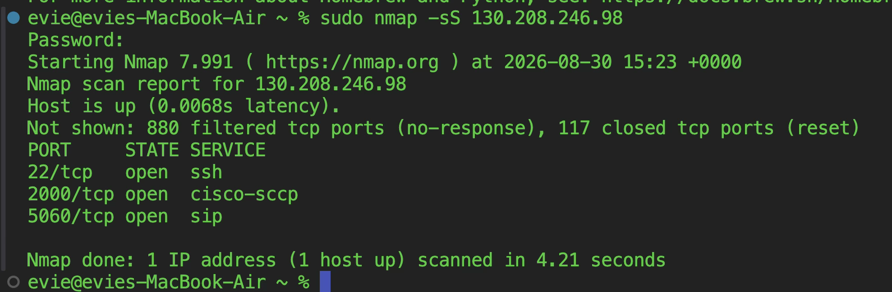
ping 130.208.246.98 works and responds with 64 byte packages taking 2-10milliseconds each depending on computer used.

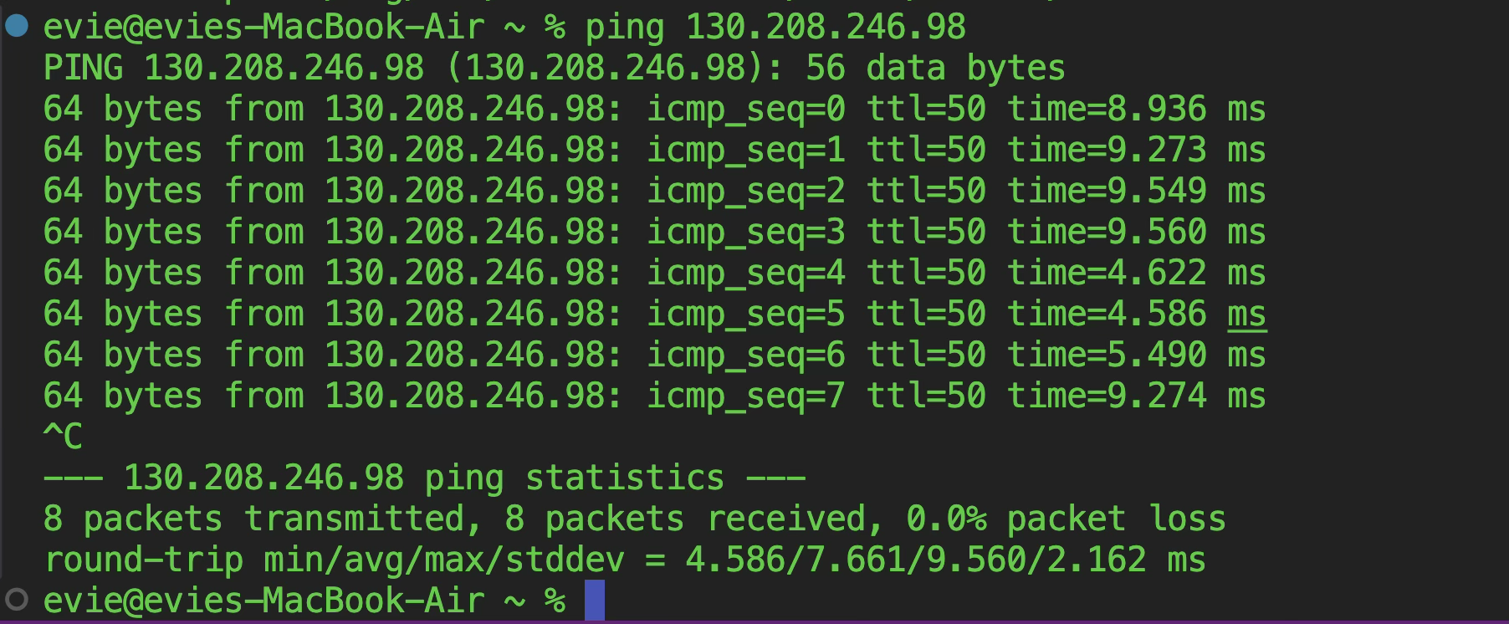

B
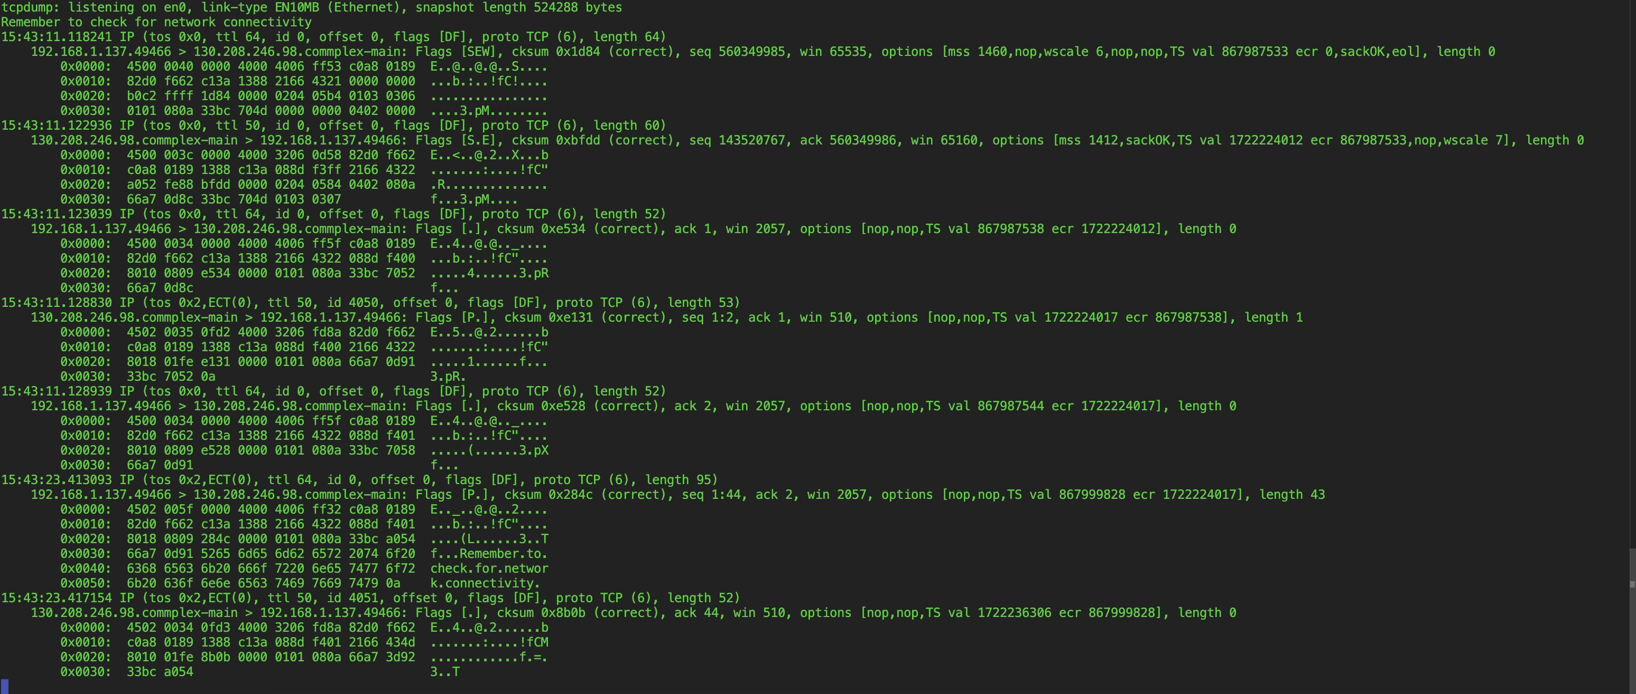

C
sudo tcpdump −vAX −i ens192 ’port 5000’ captures or monitors network traffic or packets passing through a network interface of our choice. v is verbose, A and X are both in what kind of print format we want it, -i interface is what network interface it is, port is what port we are using

ncat −ln 5000 starts a listening server that waits for a "connection", -l is listen, -n is is using a raw IP address to make it faster. 5000 is the port

ncat 130.208.246.98 5000 this is the client, the ip address is the destination, and the port is the port. the command estabilishes an outbound connection to server on port 5000.

D
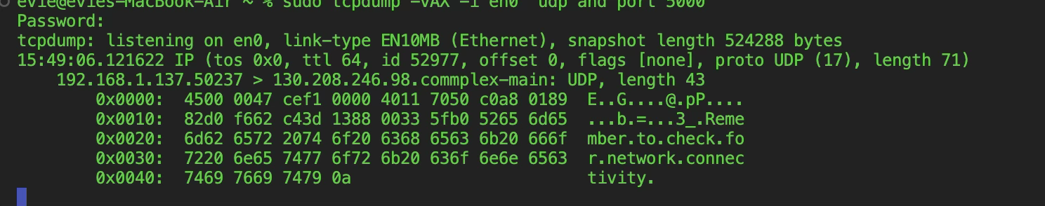

E
The TCP capture contained several packets because TCP first establishes a connection using a three-way handshake (SYN, SYN-ACK, ACK), and then uses acknowledgements when data is sent. In the UDP capture, there was no handshake; the message was sent directly in a UDP datagram. This difference occurs because TCP is connection-oriented, while UDP is connectionless.

Task 2
Code in scanner.c

The scanner found these open UDP ports:
4013
4044
4081
4052 THE EVIL PORT
We compared the result with Nmap using sudo nmap -sU -p 4000-4100 130.208.246.98. Nmap also reported ports 4013, 4044, and 4081 as open. Nmap additionally reported port 4052 as open|filtered, meaning it could not determine whether the port was open or filtered. Further testing showed it open as well. Example of scan

Starting Nmap 7.94SVN ( https://nmap.org ) at 2026-08-31 14:59 GMT
Warning: 130.208.246.98 giving up on port because retransmission cap hit (3).
Nmap scan report for 130.208.246.98
Host is up (0.0061s latency).
Not shown: 82 open|filtered udp ports (no-response)
PORT STATE SERVICE
4012/udp closed pda-gate
4013/udp open acl-manager
4016/udp closed talarian-mcast2
4020/udp closed trap
4025/udp closed partimage
4028/udp closed dtserver-port
4030/udp closed jdmn-port
4035/udp closed wap-push-http
4038/udp closed fazzt-ptp
4044/udp open ltp
4052/udp open interact
4067/udp closed idp
4071/udp closed aibkup
4073/udp closed iRAPP
4075/udp closed perimlan
4077/udp closed ascomalarm
4081/udp open lorica-in-sec
4083/udp closed lorica-out-sec
4097/udp closed patrolview

Nmap done: 1 IP address (1 host up) scanned in 8.02 seconds

